**Alpha Chemistry**

Unit 1 Case

A prestigious bracelet, insured for a large sum, has been reported stolen. The owner described the bracelet as made of pure gold, adorned with diamonds and other precious materials. Weeks later, the police located a bracelet matching the description. However, when the police returned the bracelet to the owner, the owner claimed it was a fake, that the stones were not diamonds but rather cubic zirconia and that the metal was not gold but rather gilded copper. The insurance company refuses to pay until a scientific analysis is performed to determine if the found bracelet is indeed the stolen one. Forensic Chemistry is needed to determine the authenticity of the materials in the bracelet found and solve the case.

Unit 1 Chapter 1 Case

The insurance company hired a forensic chemist to analyze the bracelet and determine its authenticity. The chemist set out to test some properties of the bracelet, such as repeated measurements to calculate the density of the metal, and compare it to the density of pure gold, which is 19.32 g/cm³. The density of gilded copper is much lower. But some decisions had to be made before testing. What conclusion would the chemist reach if the density found for the metal was 18 g/cm³? What if it was 19 g/cm³? Would 19.3 g/cm³ be close enough? Would it have to be 19.3200 g/cm³?

Unit 1 Chapter 1 Lesson 1 Case

As the forensic chemist examines the bracelet to determine if it’s the stolen item, precise and accurate measurements of the metal’s density are crucial. Small differences in the density could reveal whether the bracelet is made of pure gold or a cheaper, gilded metal. The chemist must decide how close the measured density needs to be to the true value of 19.32 g/cm³ to authenticate the bracelet, exploring the importance of both accuracy (how close to 19.32 g/cm³) and precision (consistency in repeated measurements) in making a valid conclusion.

**Unit 2: Atomic Structure and Bonding**

**Unit Phenomenon**

In northern countries, where winter brings extremely cold weather, streets and roads are often covered in ice and snow. This creates hazardous conditions for both pedestrians and drivers. Pedestrians can slip and fall, risking injury, while cars may skid on the icy surfaces, potentially causing accidents. To reduce these dangers, road salt is spread on icy streets to help melt the ice and snow. As the salt comes into contact with the ice, ice and snow seem to vanish. Metal street signs and lampposts are also exposed to the same ice and snow, but they do not vanish.

**Chapter 3: Unlocking the Atom**

Lesson 1: The Evolution of Atomic Models and Structure

Lesson 2 Atomic Number and Mass

Lesson 3: Isotopes and Atomic Variations

**Chapter 3 Phenomenon: Is Salting the Road a Magic Trick?**

How does the ice and snow vanish? Does adding salt to the road cause this reaction? To answer these questions, we must look inside the structure of the salt and the water. We start with the very basic structure of all substances, the atom. In this chapter, we will discover what atoms are. We will discover the structure of atoms. We will learn about stable isotopes and radioactive isotopes. We will learn how tracking the isotopes of water can help scientists keep the roads safe and manage water and land resources.

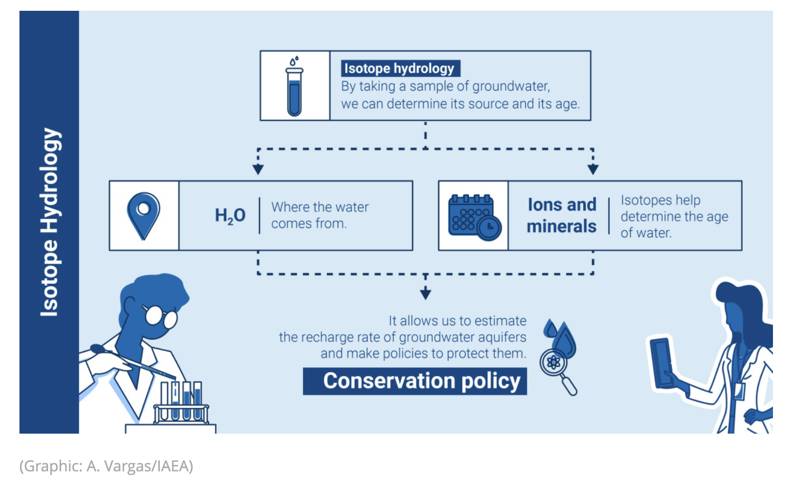

Reference: [What are Isotopes? | IAEA](https://www.iaea.org/newscenter/news/what-are-isotopes#:~:text=Atoms%20with%20the%20same%20number,and%20therefore%20in%20physical%20properties).

**Chapter 4: Electrons in Action**

Lesson 1: Electron Configuration and Quantum Numbers

Lesson 2: The Electromagnetic Spectrum and Quantized Energy

Lesson 3: The Bohr Model and Atomic Spectra

**Chapter 4 Phenomenon: Electrons as Satellites: How they Orbit the Atom**

How do the parts of the atoms interact with the parts of other atoms? Specifically, how and why do the electrons move? The movement of the electrons plays a very large role in how the salt interacts with the water to prevent ice formation. Have you seen videos of satellites orbiting the earth? You will start to see how electrons orbit the atom in a similar way. You will discover how energy is gained by some electrons, and how it is used to power these very small movements.

Suggested images:

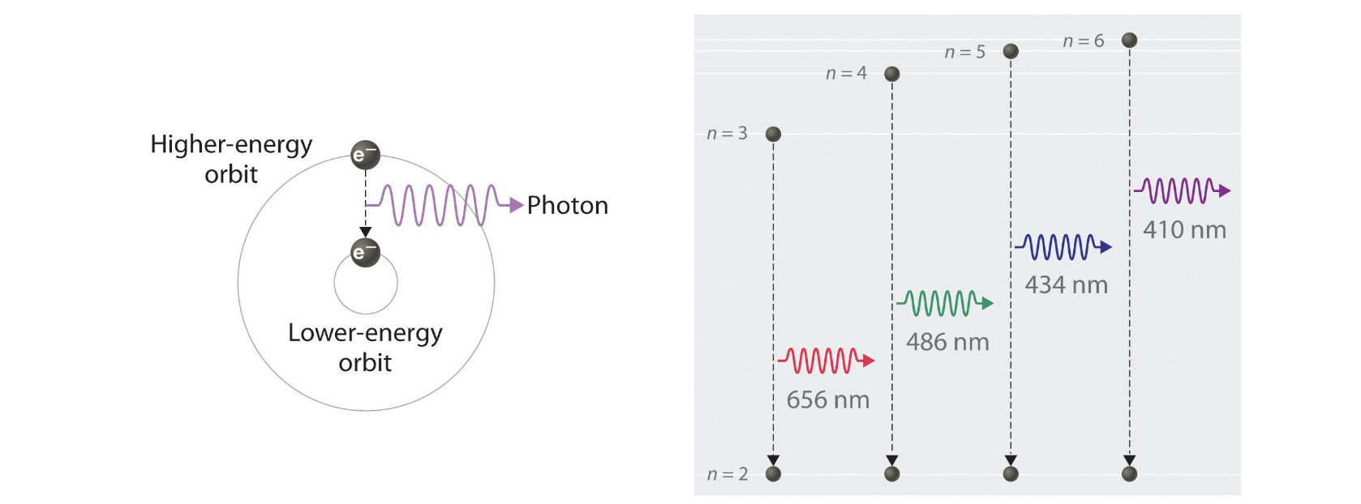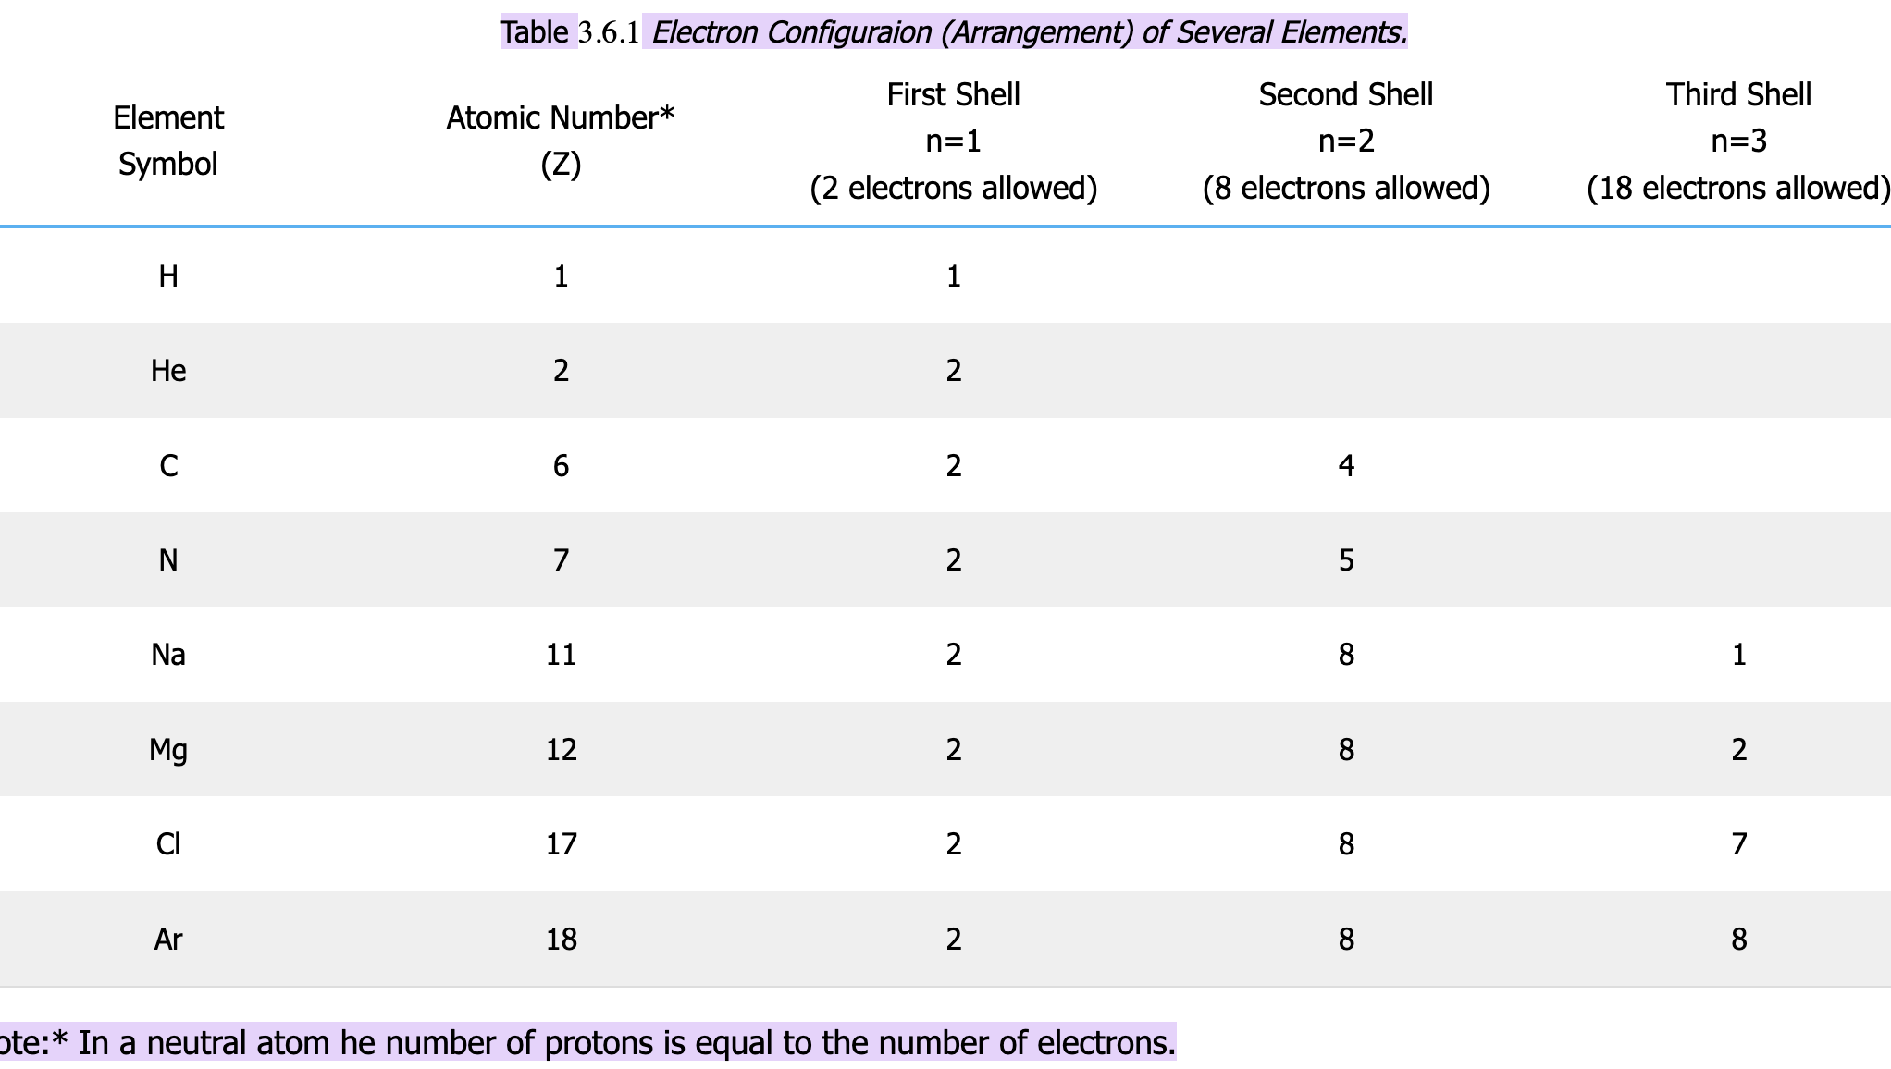

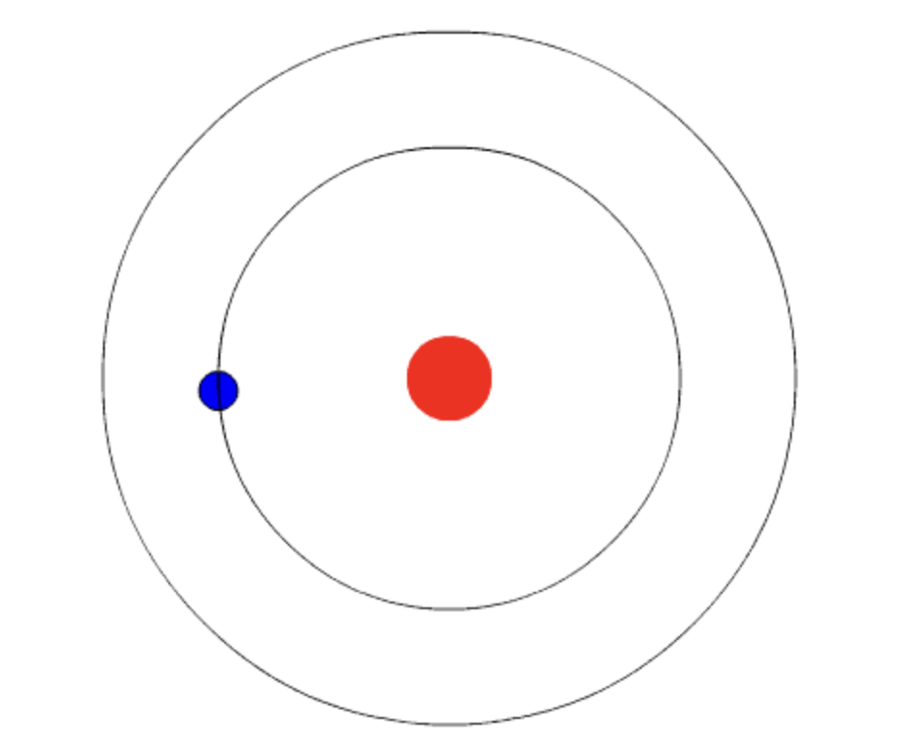

A gif or short video as shown in the reference is needed.

Reference:

[3.6: Electron Arrangement- The Bohr Model (Orbits) - Chemistry LibreTexts](https://chem.libretexts.org/Bookshelves/Introductory_Chemistry/Chemistry_for_Changing_Times_(Hill_and_McCreary)/03%3A_Atomic_Structure/3.06%3A_Electron_Arrangement-_The_Bohr_Model_(Orbits)#:~:text=model%20for%20sulfur.-,Note:%20The%20number%20of%20electrons%20that%20can%20occupy%20each%20energy,(Arrangement)%20of%20Several%20Elements.&text=Note:*,to%20the%20number%20of%20electrons).

**Chapter 5: The Periodic Table and Chemical Trends**

Lesson 1: The Development of the Periodic Table

Lesson 2: Classifying Elements

Lesson 3: Periodic Trends and Predicting Properties of Elements

**Chapter 5 Phenomenon: Which Type of Salt and Why?**

Three salts are commonly used to clear the roads of ice. Sodium chloride, magnesium chloride, or calcium chloride. Do you notice that all of these contain “chloride”? But all also contain another element: sodium, magnesium, or calcium. What qualities do these elements have in common? Is there a way to predict which elements have similar properties? Sometimes, these salts are spread on roads or bridges before freezing weather; why do you think this is?

Note to writer, in the first paragraph relate the development of the periodic table to the ability to predict the common qualities and properties of elements.

Reference: [How Does Salt Battle Road Ice? | PBS News](https://www.pbs.org/newshour/science/why-does-salt-melt-road-ice)

**Chapter 6: Ionic and Metallic Bonding**

Lesson 1: Formation and Properties of Ions

Lesson 2: Ionic Bonding and Compound Formation

Lesson 3: Naming and Formulas of Ionic Compounds

**Chapter 6 Phenomenon: Salt vs. Metal, Why Does Water Treat Them Differently?**

When road salt is spread on icy and snowy streets, the ice and snow melt and the salt dissolves in the water. Street signs and lamp posts are made of metal, but they do not melt the snow or dissolve in water. Instead, they remain intact, showing no immediate signs of rust or corrosion. Why do salt and metal behave so differently with water?

**Chapter 7 Covalent Bonding**

Lesson 1: Covalent Bonding and Molecular Structure

Lesson 2: Naming and Writing Formulas for Covalent Compounds

Lesson 3:VSEPR Theory and Molecular Geometry

Lesson 4: Electronegativity, Polarity, and Intermolecular Forces

**Chapter 7 Phenomenon:**

Water has many special properties. The interaction of these properties with salts are what melt ice on roads. Some of these properties are:

* Density (of ice and liquid water)
* Covalent Bonding
* Electronegativity
* Solubility
* Cohesion
* Polarity.

These concepts are important concepts in chemistry. What exactly do the salt compounds do to the water that melts the ice? What happens to the chemical bonds when the salt dissolves in the water? What is the shape of the water molecules? Do the salts affect this shape? Is there a way to predict the general shape of molecules?

**References:**

[The Chemistry of Road Salt And How It Works](https://www.americanchemistry.com/chemistry-in-america/news-trends/blog-post/2018/the-chemistry-of-road-salt-and-how-it-works)

[Lesson summary: Water and life (article) | Khan Academy](https://www.khanacademy.org/science/ap-biology/chemistry-of-life/structure-of-water-and-hydrogen-bonding/a/hs-water-and-life-review)

[How Does Salt Battle Road Ice? | PBS News](https://www.pbs.org/newshour/science/why-does-salt-melt-road-ice)

Suggested image:

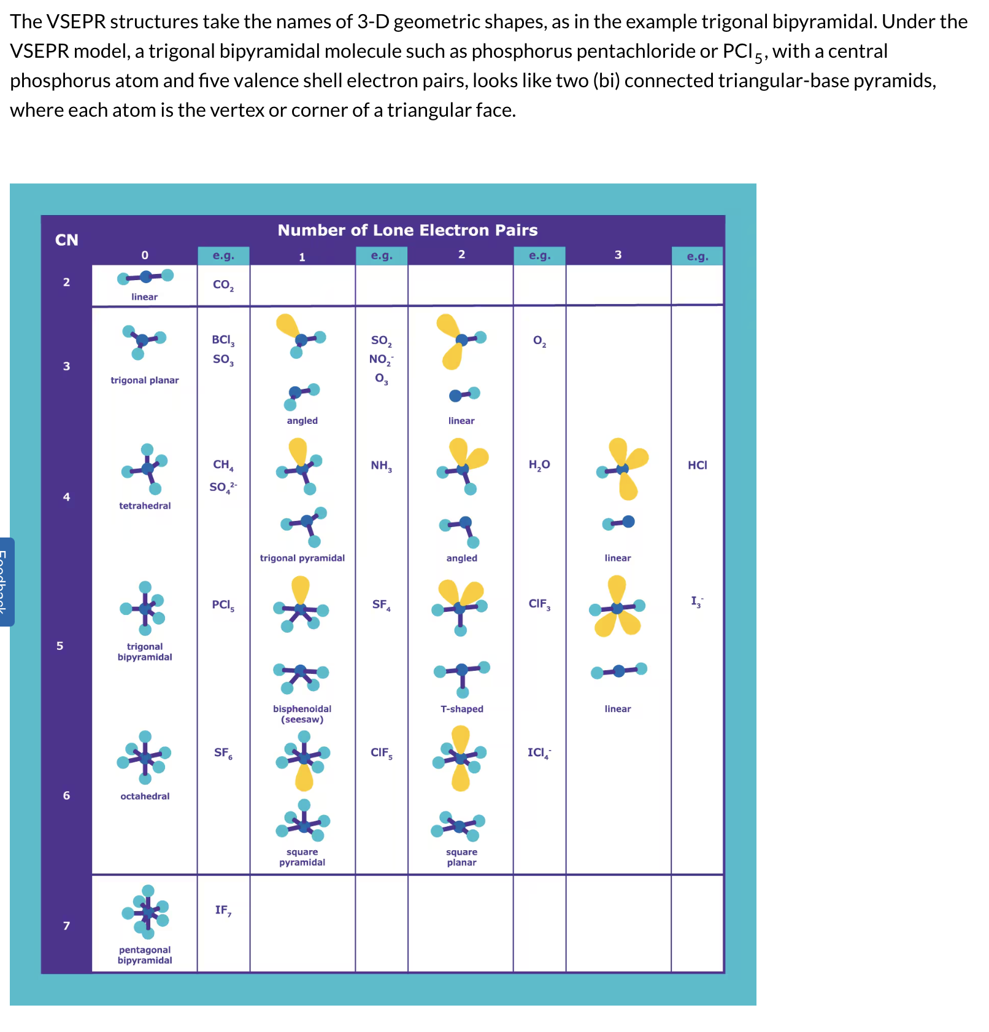

# Unit 3

**Big Idea:**

The Transformative Power of Reactions: Chemical reactions are the essence of transformation, where atoms rearrange to form new substances. In exploring stoichiometry and the mole concept, we gain the ability to quantify these transformations, predicting outcomes and balancing reactions with precision. From the smallest change in matter to the grandest chemical processes, we are empowered to understand and harness the energy and order behind every reaction.

**Unit Phenomenon:**

How can chemical reactions help improve safety features?

Background:

Car accidents are a major cause of injuries and fatalities worldwide. Road safety is a critical concern implemented by governments to reduce accidents. Cars manufacturers also aim at reducing risks by including two major safety features: seat belts and airbags. Front airbags reduce driver fatalities in frontal crashes by 29% and fatalities of front-seat passengers aged 13 and older by 32% ; side airbags that protect the head reduce a car driver’s risk of death in driver-side crashes by 37% and an SUV driver’s risk by 52%. Overall, airbags can reduce passenger injuries by 50% in a car accident. In the event of a car crash, sensors trigger the airbags to deploy rapidly to cushion and protect passengers. The cushion is provided by gas that is rapidly released from a chemical reaction inside the airbag. The airbag inflates due to the gas from the chemical reaction. But the products of the chemical reaction should also be safe for passengers. For example, excess sodium metal can react violently with moisture in the air.

**Unit Assessment:**

Design a set of reactions and lab instructions to synthesize a product. Include the steps necessary, the equations, and the theoretic yield.

## Chapter 8: Chemical Reactions

**Chapter Phenomenon:**

How does an automobile airbag safety system work? Automobile airbags provide cushion due to a chemical reaction that releases gas and rapidly inflates the airbag. There are different types of chemical reactions. For example, some decompose substances, others burn materials, and others synthesize a product. What type of chemical reaction takes place in the deflated airbag when needed? What starts the chemical reaction? What are the parameters that make this contained chemical reaction safe?

**Chapter task:**

Research the chemical reactions that occur in an automobile airbag safety system. Then balance and classify it.

**Lesson 1:** Writing and Balancing Chemical Equations

**Lesson Phenomenon:** What are the chemical reactions of the air bag system? What is the correct **ratio** of chemical ingredients that you need? When writing and balancing chemical reactions, we need to make sure we do not violate the principle of conservation of matter.

**Activity:**

Set up a teacher’s demonstration that follows the video "The Carbon Tree" or [Carbon Snake](https://youtu.be/DQfn5EOORuM?feature=shared) separation of elemental carbon and water from table sugar using sulfuric acid (H2SO4 + C12H22O11 → 12C and 11H2O).

**Lesson 2:** Types and Classification of Chemical Reactions

**Lesson Phenomenon:** Do all chemical reactions release gas like the airbags? Is there a way to classify chemical reactions according to what they do?

Lab: (½ to full class period): Modify this, do not include mole calculations, save them for Molar Mass lesson: <https://www.flinnsci.com/api/library/Download/2f1763d4857c46728ef4bf690872c608?srsltid=AfmBOoocGFwvxtBbpF1lNYwVzzjes-IPoz3c_teuF_Qb2Bj2PXSMKgKM>

## Chapter 9: The Mole and Chemical Quantities

**Chapter Phenomenon:** The design of automobile safety airbags has to include the amount of gas released. If it is not enough, the airbag would not provide sufficient cushion, but if it is too much it could overinflate, suffocate, and kill rather than protect the passenger. What is the correct ratio of reactants?

**Chapter task:**

Present several ways in which matter can be measured and the equivalence between those ways, such as the number of particles, their mass, or their volume.

**Lesson 1:** **The Mole Concept and Avogadro's Number**

**Lesson Phenomenon****:** To measure the amount of each reactant in the airbag reaction involves measuring matter. How can matter be measured? For sure, putting it on the scale and determining its mass is one way. But the Periodic Table shows that atoms of different elements weigh differently, so to what extent does the mass of a reactant give information that can easily be inserted in a chemical equation to represent the reaction? What is the bridge between the atomic masses included in the Periodic Table and the real world where we measure masses?

Lab: (½ to full class period): Modify this to include the mole calculations: <https://www.flinnsci.com/api/library/Download/2f1763d4857c46728ef4bf690872c608?srsltid=AfmBOoocGFwvxtBbpF1lNYwVzzjes-IPoz3c_teuF_Qb2Bj2PXSMKgKM>

**Lesson 2: Molar Mass**

**Lesson Phenomenon:** Matter is measured by the mole concept, but how could chemists count the number of atoms or molecules in a reactant? That is impossible! We need a more practical way to measure substances. Putting them on the scale and determining their m mass is one way. But the Periodic Table shows that atoms of different elements weigh differently, so to what extent does the mass of a reactant give information about the amount of matter in a sample What is the bridge between the atomic masses included in the Periodic Table and the real world where we measure masses?

Lab: (½ to full class period): Modify this to include the molar masses calculations: <https://www.flinnsci.com/api/library/Download/2f1763d4857c46728ef4bf690872c608?srsltid=AfmBOoocGFwvxtBbpF1lNYwVzzjes-IPoz3c_teuF_Qb2Bj2PXSMKgKM>

**Lesson 3: Density and Molar Volume**

**Lesson Phenomenon:** The airbag reaction produces a gas. The amount of matter in a gas can be measured like the amount of matter in any substance, by moles. But how practical is it to measure the mass of a gas? Gases occupy a lot of space, so it is hard to put them on a scale. Is there a concept equivalent to molar mass but that is more practical for liquids and gases?

**Activity:** Use this animation as an inspiration for the students to create a PSA that explains the lesson. (Animation here: [https://gizmos.explorelearning.com/find-gizmos/lesson-info?resourceId=362](https://www.explorelearning.com/gingerneering-contest?resourceId=362))

## Chapter 10: Stoichiometry

**Chapter Phenomenon:**

Now you have several ways to measure matter, by quantity of particles, mass, or volume. But how do those quantities relate to each other in a chemical equation? What is the ratio in which they react?

**Chapter task:**

Research the volume of gas needed for the automobile airbag. Then, calculate the amount of each reactant needed to produce the desired volume of the airbag and calculate the amount of the by-products taking into account possible reactant impurities, limiting reactants, and reaction yield. Create a PSA using a video podcast, an audio podcast, a social media campaign, infographic, or write an appeal to a well-known business to inform of your findings.

**Lesson 1: Stoichiometric Calculations**

**Lesson Phenomenon:** To design an automobile airbag a precise amount of each reactant is needed. In what proportions will the reactants react?

Activity: Modify this: <https://www.chemedx.org/article/airbag-challenge>

**Lesson 2: Purity of Reactants and Percent Yield**

**Lesson Phenomenon:**

After a new airbag manufacturer has calculated the exact amounts of each reactant (guanidinium nitrate and a copper nitrate oxidizer) needed for the desired size of the airbag, the provider of drugs informs that by mistake there was a contamination in the substances. This is a serious problem because if there is less reactant then the volume of the airbag will be smaller and will not be efficient as a safety device. The airbag manufacturer can go bankrupt and even face legal issues due to passengers getting hurt. But the problems did not end there .... A chemist informed the manager that the chemical reaction involved in the airbag does not proceed to completion; that is even with absolutely pure reactants, a certain proportion of them will not react. How can the airbag manufacturer adjust the quantities to account for all these issues?

**Lesson 3: Limiting Reactants**

**Lesson Phenomenon:** After the airbag manufacturer calculated the right amount of each reactant and took into consideration their purity as well as the reaction yield, the technicians from the plant informed that they were short in one of the reactants. Would this impact the reaction if there is abundance of the other reactant? How would this impact the volume of the airbag?

Use: Limiting Reactant from this page: <https://www.dlt.ncssm.edu/core/c6.htm> or comparable YouTube short, etc.

**Lesson 4: Hydrates: Their Formulas and Reactions**

**Lesson phenomenon:** Water is a tricky substance, and it is often involved in many chemical reactions. Sometimes water stands by itself in a reaction but other times it is part of other substances, like it integrates their formula! These are called hydrates. How would hydrates affect a chemical reaction? How should they be counted?

Lab: (½ to full class period): Modify this: <https://www.chemedx.org/activity/stoichiometry-free-virtual-chemistry-lab-activity>

# Chemistry Unit 4 Phenomenon

# The Thermodynamics House: Can You Solve the Puzzles and Escape?

You and your classmates find yourselves trapped in a 2-story high-tech laboratory escape house. To unlock the final door and escape the house, you must solve a series of puzzles presented to you in each room. The puzzles explore how energy flows through chemical reactions and how these reactions behave under different conditions.

Chapter 11: Reaction Rates and Equilibrium

## Chapter 11 Phenomenon

In the first story of the house, there are rooms in which the puzzles related to controlling how fast reactions occur and how they reach a state of balance.

Lesson 1: Factors Affecting Reaction Rates

### Lesson 1 Phenomenon: "Speeding Up or Slowing Down"

As you enter the first room, a large, locked box sits in the center; it contains the key to open this room and move to room number 2. The box will unlock if you manage to decompose hydrogen peroxide and produce at least **50 bubbles** of oxygen gas within **5 minutes**. Surrounding the box, there are labeled bottles containing different solutions: water, manganese dioxide, potassium iodide, and various concentrations of hydrogen peroxide (H₂O₂).

Lesson 2: Deciphering Reaction Rate Laws

### Lesson 2 Phenomenon: "Decoding the Rate Equation"

In the next room, a large screen displays a complex rate law formula that is still incomplete. The door of this second escape room will open when you correctly complete the formula. To do that, you need to conduct some experiments to determine how changing concentrations of iodine and acetone affects their reaction rate.

Lesson 3: Balancing Reactions with Le Chatelier's Principle

### Lesson 3 Phenomenon: "Finding Equilibrium"

As you enter this room, you encounter an experimental setup involving an equilibrium reaction between iron (III) chloride (FeCl₃) and potassium thiocyanate (KSCN).

* **Beaker 1:** Contains a solution of **iron (III) chloride (FeCl₃)**, which is a clear yellow solution.
* **Beaker 2:** Contains a solution of **potassium thiocyanate (KSCN)**, which is also clear.

When mixed, these two solutions react to form **iron(III) thiocyanate (Fe(SCN)³)**, which produces a striking red color. The reaction can be represented as follows:

Fe3+(aq)+SCN−(aq)⇌Fe SCN 2+(aq)Fe3+(*aq*)+SCN−(*aq*)⇌Fe SCN 2+(*aq*)

To unlock the passage leading you to your next destination in the escape house you have to manipulate the conditions of this reaction to achieve a deep red color. You can add more reactants, change their concentration, or adjust temperature.

Lesson 4: Finding the Equilibrium Constant

### Phenomenon: "The Constant Challenge"

As you enter the last room of the first floor, you find a well-organized laboratory setup featuring a reaction between **hydrogen gas (H₂)** and **iodine gas (I₂)** to form **hydrogen iodide (HI)**. To unlock the door that leads you to the second floor of this high-tech laboratory escape house, you need to determine the equilibrium constant (K) for the reaction at a specific temperature (25°C). The room contains equipment to help you measure the concentrations of each gas.

Chapter 12: Unlocking the Power of Thermochemistry

## Chapter 12 Phenomenon

The second floor of the escape house is devoted to studying the energy involved in chemical reactions. How does energy transfer occur during chemical processes, how much energy is absorbed or released, and how these values can be calculated and manipulated for your escape?

Lesson 1: Energy and Chemical Reactions

### Lesson 1 Phenomenon: "Energy in Motion"

The first escape room on the second floor is filled with locked cabinets marked by various reaction formulas (e.g., sodium bicarbonate with vinegar). Your challenge is to sort these reactions based on whether they absorb or release energy. If you do it correctly, the door of this room will unlock, and you will be able to go into the next room.

Lesson 2: Calorimetry and Heat Transfer

### Lesson 2 Phenomenon**:** "Measuring Heat"

In this laboratory setup featuring a calorimeter at its center, your task is to measure heat transfer during an endothermic reaction involving ammonium nitrate dissolving in water. Carefully record temperature changes as you add 5 grams of ammonium nitrate to 100 mL of water in the calorimeter setup provided in this room. Calculate how much heat is absorbed during dissolution based on temperature changes observed over time. Each accurate measurement reveals another piece of your escape code that brings you closer to freedom.

Lesson 3: Calculating Enthalpy Changes with Hess's Law

### Lesson 3 Phenomenon: "The Pathway to Escape"

You have now reached the second to last room of the escape house! Your challenge for this room is to find missing enthalpy values based on provided enthalpy values for each reaction step displayed on interactive screens around the room. Each correct calculation helps piece together clues leading you closer to unlocking your final exit.

Lesson 4: Predicting Spontaneity with Gibbs Free Energy

### Lesson 4 Phenomenon**:** "The Spontaneous Decision"

In your final challenge, you will analyze if calcium carbonate spontaneously decomposes at different temperatures. You will have to take into account not only the energy involved in reactions but also the state of disarray. Successfully predicting which reactions are spontaneous allows you to solve the final puzzle that unlocks the door leading out of the escape room!